**Insert School Logo**

**Semester One Examination 2019**

**Question/Answer Booklet**

**MATHEMATICS SPECIALIST**

**UNIT 1**

**Section One:**

**Calculator-free**

|  |
| --- |
| Student Name: _____________________________________ |
| Teacher‘s Name: _____________________________________ |
|  |

**Time allowed for this section**

Reading time before commencing work: five minutes

Working time for paper: fifty minutes

**Material required/recommended for this section**

**To be provided by the supervisor**

This Question/Answer booklet

Formula Sheet

**To be provided by the candidate**

Standard items: pens(blue/black preferred), pencils(including coloured), sharpener, correction tape/fluid, erasers, ruler, highlighters

Special Items: nil

**Important note to candidates**

No other items may be taken into the examination room. It is **your** responsibility to ensure that you do not have any unauthorised notes or other items of a non-personal nature in the examination room. If you have any unauthorised material with you, hand it to the supervisor **before** reading any further.

**Structure of this paper**

|  |  |  |  |  |
| --- | --- | --- | --- | --- |
|  | Number of questions available | Number of questions to be attempted | Suggested working time (minutes) | Marks available |
| **Section One**  **Calculator—free** | **6** | **6** | **50 minutes** | **53** |
| Section Two  Calculator—assumed | 11 | 11 | 100 minutes | 97 |
|  | | | | 150 |

**Instructions to candidates**

1. The rules for the conduct of Western Australian external examinations are detailed in the *Year 12 Information Handbook 2019.* Sitting this examination implies that you agree to abide by these rules.
2. Answer the questions according to the following instructions.

Section One: Write answers in this Question/Answer Booklet. Answer **all** questions.

**Show all your working clearly.** Your working should be in sufficient detail to allow your

answers to be checked readily and for marks to be awarded for reasoning. Incorrect

answers given without supporting reasoning cannot be allocated any marks. For any

question or part question worth more than two marks, valid working or justification is

required to receive full marks. If you repeat an answer to any question, ensure that you

cancel the answer you do not wish to have marked.

It is recommended that you **do not use pencil**, except in diagrams.

1. You must be careful to confine your responses to the specific questions asked and to follow any instructions that are specific to a particular question.
2. Spare pages are included at the end of this booklet. They can be used for planning your responses and/or as additional space if required to continue an answer.

* Planning: If you use the spare pages for planning, indicate this clearly at the top of the

page.

* Continuing an answer: If you need to use the space to continue an answer, indicate in the original answer space where the answer is continued, i.e. give the page number. Fill in the number of the question that you are continuing to answer at the top of the page.

1. The Formula Sheet is **not** handed in with your Question/Answer Booklet.

# Section One: Calculator–free 53 marks

This section has **six (6)** questions. Attempt **all** questions. Write your answers in the spaces provided.

Working time: 50 minutes

**Question 1 (6 marks)**

The diagram below shows the vectors $u$ and $v$.

Using a ruler draw an accurate diagram of each of the following on the sketch below.

All your vector answers must start from O.

(a) $u+2v$ (2 marks)

(b) $v-u$ (2 marks)

(c) $-\left|u\right|×\frac{v}{\left|v\right|}$. (2 marks)

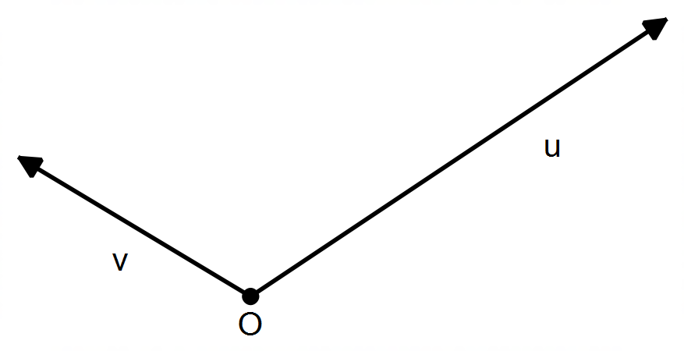

**Question 2 (14 marks)**

(a) Points P and Q have position vectors $\left(\begin{matrix} 3 \\ -5\end{matrix}\right)$ and $\left(\begin{matrix}4 \\ α\end{matrix}\right)$ respectively, with $α∈R$.

Justifying your answers, determine the value(s) of $α$ so that:

(i) OP is parallel to OQ. (2 marks)

(ii) OQ is perpendicular to $i+j$. (2 marks)

(iii) PQ is a unit vector. (2 marks)

(iv) ΔOPQ is isosceles with PQ as its base. (2 marks)

**(Question 2 – Continued)**

(b) The unit vectors $i$ and $j$ are called “reference vectors” because they can be combined to obtain any other vector in 2D space, however any other two non-parallel vectors can be used.

The vectors $u$ and $v$ shown below are chosen as the new reference vectors in 2D.

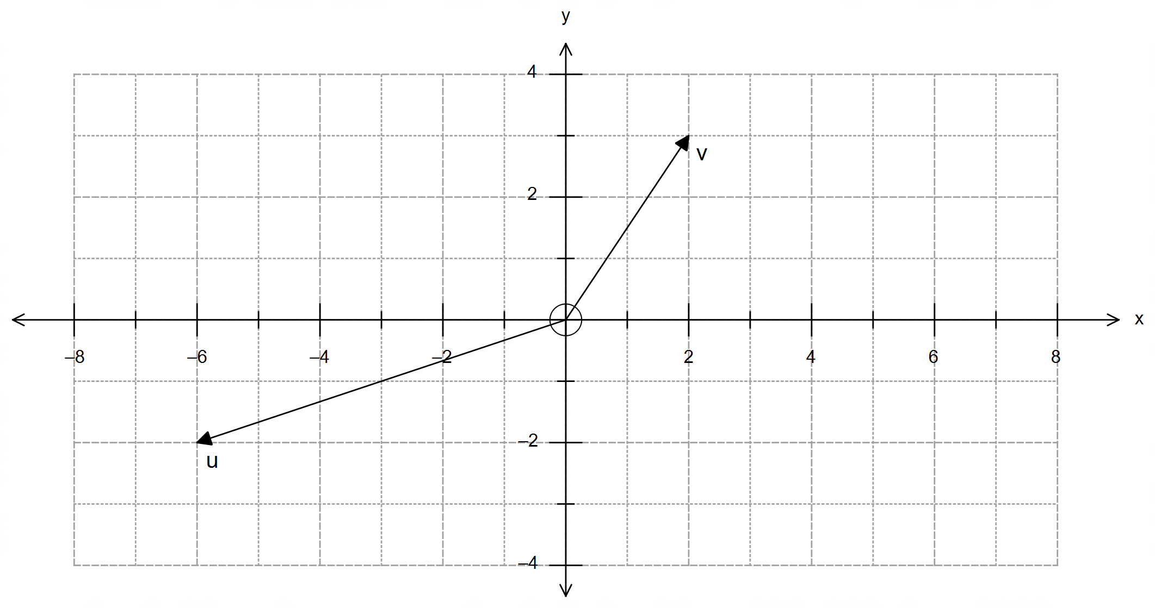

(i) Obtain an expression for both $i$ and $j$ in terms of $u$ and $v$. Show your working clearly.

(4 marks)

(ii) Hence, or otherwise, write vector $r=14i+7j$ in terms of $u$ and $v$. (2 marks)

**Question 3 (6 marks)**

(a) If $18!=k$, then express each of the following in term of $k$.

(i) $20!-18!$ (2 marks)

(ii) $\frac{{}_{ }^{20}{P_{17}}}{{}_{ }^{21}{C_{3}}}$ (2 marks)

(b) Show that ${}_{ }^{n}{C_{r}}={}_{ }^{n}{C_{n-r}}$ is true for all integers $n,r$ with $n>r$. (2 marks)

**Question 4 (8 marks)**

Consider the following statements.

A: If $m>m^{2}$, with $m∈R$, then $m<1$.

B: If a parallelogram has congruent diagonals, then the parallelogram is a rectangle.

C: $∀ p∈Q,∃ a,b∈Z:p=\frac{a}{b}$

(a) State the converse of statement A. Is the converse always true? If yes, then explain

why it is always true; if not provide a counter example and adjust the domain of $m$ so

that the converse is always true. (4 marks)

(b) Write down the contrapositive of statement B. Is the contrapositive always true? Explain.

(2 marks)

(c) Rewrite statement C in words. (2 marks)

**Question 5 (13 marks)**

Consider the portion of Pascal’s triangle shown below.

|  |  |  |  |  |  |  |  |  |  |  |  |  |  |  |  |  |  |  |  |  |  |  |  |
| --- | --- | --- | --- | --- | --- | --- | --- | --- | --- | --- | --- | --- | --- | --- | --- | --- | --- | --- | --- | --- | --- | --- | --- |
|  | |  | |  |  | |  |  | 1 | | 2 | | 1 | |  |  | |  |  | |  |  | |
|  | |  | |  |  | |  | 1 | | 3 | | 3 | | 1 | |  | |  |  | |  |  | |
|  | |  | |  |  | | 1 | | 4 | | 6 | | 4 | | 1 | | |  |  | |  |  | |
|  | |  | |  | 1 | | | 5 | | 10 | | 10 | | 5 | | 1 | | |  | |  |  | |
|  | |  | | 1 | | | 6 | | 15 | | 20 | | 15 | | 6 | | | 1 | | |  |  | |
|  | | 1 | | | 7 | | | 21 | | 35 | | 35 | | 21 | | 7 | | | 1 | | |  | |
|  | 1 | | 8 | | | 28 | | | 56 | | 70 | | 56 | | 28 | | 8 | | | 1 | | |  |

(a) Determine each of the following powers using the elements of Pascal’s triangle.

Show your working clearly.

(i) $2^{6}$ (1 mark)

(ii) ${11}^{5}$ [Hint: 11 = 10 + 1] (2 marks)

(b) State the value(s) of $x$ in each case below.

(i) ${}_{ }^{6}{C_{x}}=20$ (1 mark)

(ii) ${}_{ }^{x}{C_{5}}=21$ (1 mark)

(iii) ${}_{ }^{x}{C_{2}}={}_{ }^{x}{C_{6}}$ (1 mark)

**(Question 5 – Continued)**

(c) Use the elements of Pascal’s triangle to expand and simplify ${\left(2x-y\right)}^{5}$. (3 marks)

(d) An academic team of 5 members is to be composed from 3 chemists, 3 biologists and 2 environmentalists. How many different teams of 5 academics can be assembled if:

(i) there are no other restrictions? (1 mark)

(ii) both environmentalists must be chosen? (1 mark)

(iii) it must contain at least two chemists? (2 marks)

**Question 6 (6 marks)**

The figure below shows triangle $OAB$.

Point $C$ is the midpoint of $OB$, and $CE$ crosses $AB$ at the point $D$ such that $AD:DB = 2:3$.

Let $\vec{OA} =a$ and $\vec{OB} =b$.

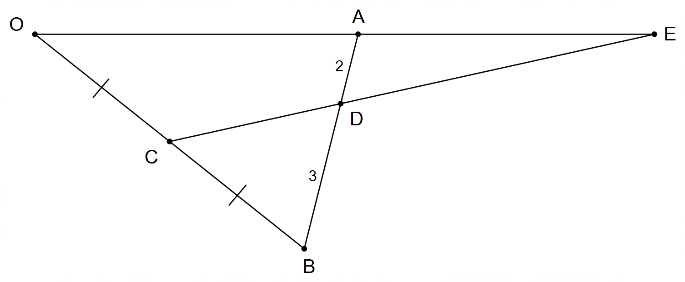

(a) Determine $\vec{AD}$ and $\vec{CD}$ in terms of $a$ and $b$. (3 marks)

**(Question 6 – Continued)**

(b) If $\vec{OE}=α\vec{OA}$ and $\vec{CE}=β\vec{CD}$, use the fact that $\vec{OC}+\vec{CE}=\vec{OE}$ to determine $α$ and $β$. (3 marks)

**End of Section One**

**Additional working space**

Question number(s): ……………………

**Additional working space**

Question number(s): ……………………

**Additional working space**

Question number(s): ……………………

**Additional working space**

Question number(s): ……………………